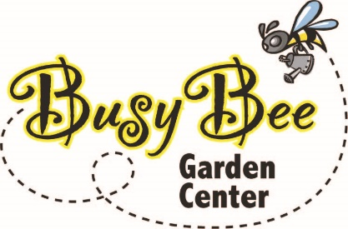 |  | Bundle Order Form

Busy Bee Garden Center  5901 Hwy 65-69  Indianola, IA 50125  (515) 408 – 5322  [email] | Please submit to order@growbusybee.com  Date: Click here to enter a date.

Contact Information
Name: Click here to enter text. Email: Click here to enter text.
Contact Phone Number: Click here to enter text.
Delivery Address (please add special instructions): Click here to enter text.

Product Details (More lines provided on the next page)
Bundle Description Quantity
Delivery:
Tax:
Grand Total:

For “Sun & Shade” bundles:
Sun level: ☐Morning Sun ☐Afternoon Sun ☐Both (Full Sun) ☐Shade
Planter size: ☐12-15” ☐16-20” ☐20-24” ☐other: Click here to enter text.
Desired color scheme (you may select more than one): ☐Red ☐Orange ☐Yellow ☐Pink ☐Purple ☐White ☐Foliage ☐other: Click here to enter text.
Does the planter attract hot sun all day long? ☐Yes ☐No
Payment Information
☐Credit Card
Name on Card: Click here to enter text.
Card Type: Visa ☐ MasterCard ☐ American Express ☐ Discover ☐ Apple Pay ☐ Google Pay ☐
Card Expiration: Click here to enter a date.
Credit Card No.: Click here to enter text. Security Code (CVV): Click here to enter text.

☐Cash* ☐Check*
* Available for pickup orders ONLY

Additional Comments (i.e. are there plants you do or do not want included in your bundle?): Click here to enter text.

Thank you for ordering from Busy Bee!

