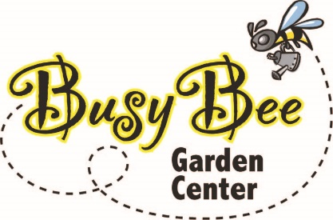 |  | Order Form

Busy Bee Garden Center  5901 Hwy 65-69  Indianola, IA 50125  (515) 408 – 5322  [email] | Please submit to order@growbusybee.com  Date:

Contact Information
Name: Email:
Contact Phone Number:
Delivery Address (please add special instructions):

Product Details (More lines provided on the next page)
Item Description Quantity
Delivery:
Tax:
Grand Total:

Payment Information
☐Credit Card
Name on Card:
Card Type: Visa ☐ MasterCard ☐ American Express ☐ Discover ☐ Apple Pay ☐ Google Pay ☐
Card Expiration:
Credit Card No.: Security Code (CVV):

☐Cash* ☐Check*
* Available for pickup orders ONLY

Thank you for ordering from Busy Bee!
Please use this page for additional items!

Item Description Quantity

